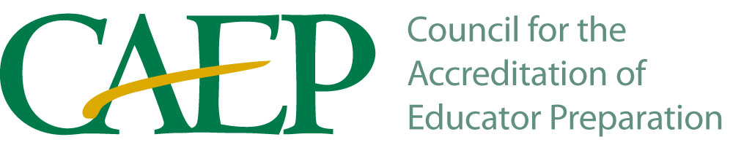
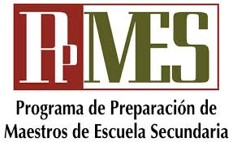
Student Teaching Evaluation Form (Formative)

Student _________________________________________ | Semester______________________ | Date______________________
School ___________________________________________ | Grade(s)_______________________ | Subject____________________
Supervisor_________________________________________ | Cooperating Teacher__________________________________________

Directions: Score in .5 Segments (1-1.5 Emerging, 2-2.5 Developing, 3-3.5 Proficient, 4-Accomplished, N/0-Not Observed: See Scoring Rubric)

The Learner and Learning: Learner Development

____ 1. Designs instruction to address learners’ development, Candidate’s Teaching Abilities (Required)
individual strengths, prior knowledge, and experience.
_____2. Uses resources effectively, including appropriate technology.
Management of the Learning Environment

_____3. Creates a safe, positive learning environment based on respect, positive social interaction, active engagement in learning, and self-motivation.

_____4. Communicates behavioral expectations to learners.

_____5. Employs effective management strategies and maintains consistent standards for behavior in the learning environment.

Instructional Practice

_____6. Creates and uses instructional plans that incorporate critical/creative thinking, problem solving, and collaboration.

_____7. Creates and implements learning experiences that help build accurate conceptual understanding, content knowledge, and academic language.

_____8. Aligns instructional procedures and assessments with identified learning objectives.

_____9. Designs and implements sequential instruction that supports learners in meeting curriculum goals.

____10. Develops and uses learning experiences that support literacy (reading, writing, speaking, listening).

____11. Uses a variety of appropriate instructional strategies to meet the needs of all learners.

____12. Provides clear, accurate lessons.

____13. Provides instruction that makes connections to learners’ prior knowledge and experiences.

____14. Engages learners through inquiry methods.

____15. Engages learners in applying content knowledge to real world problems.

____16. Models critical/creative thinking, problem solving skills, and collaboration.

____17. Uses multiple methods of assessment to monitor progress; creates opportunities for students to demonstrate understanding in diverse ways.

____18. Provides opportunities for learners to monitor their own learning.

____19. Adapts instruction according to assessment of learning and provides feedback to learners.

Professional Responsibility (evaluated by observation and interview)

____20. Uses feedback from professionals and assessments of student learning to evaluate and improve his/her teaching practice.

____21. Self-evaluates the effects of his/her choices and actions on others.

____22. Advocates, models, and teaches safe, legal, and ethical behavior including the use of information and technology.

____23. Collaborates with others to reflect on, plan, and improve instruction

____24. Collects and evaluates evidence to measure student learning.

TEACHER CANDIDATE SIGNATURE ____________________________

EVALUATOR SIGNATURE _______________________________
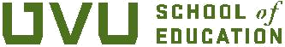
□ Cooperating Teacher □ Supervisor

