Agenda
Wednesday, June 21, 2017
7:30am - 8:30am | Registration & Breakfast
8:30am - 12:30pm  Coffee Break @ 10:00am - 10:30am | Workshop: “Practice-Based and Practice-Led Research in Entrepreneurship: The Challenge of Collaborative Writing a Journal Article”  by Dra. Maria Amador  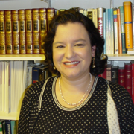  Congratulations, you are a professor of entrepreneurship with service, teaching and research experience! Despite your arduous work and achievements, you may not have the time to delve deeper into practice-based and practice-led research in entrepreneurship. If you are interested in doing collaborative research, and publishing in impact-ranked academic journals, this workshop is for you. The topics to cover are practice-based and practice-led research, collaborative research, researchers’ rules and contracts, research project management tools, call for papers, and the challenge.
12:30pm - 1:30pm | Lunch
1:30pm - 5:30pm Coffee Break @ 12:30pm - 1:30pm | Workshop: “Creative Jumpstart/A Ingeniártelas”  by Angiemille Latorre  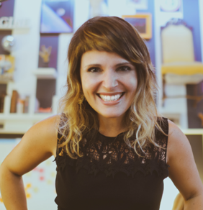  Discover how thinking styles impact personal and professional success. Use those discoveries to improve leadership and manage high performance teams of diverse thinkers. This exercise is based on proven research designed to increase creativity and innovation potential.
5:30pm - 7:30pm | Networking Session

Agenda
Thursday, June 22, 2017
7:30am - 8:30am | Registration & Breakfast
8:30am - 10:00pm | Partners Exposition      
10:00am-10:30am | Coffee Break
10:30am - 12:30pm | 1st Session  Workshop: “The power of words and the body”  by Dra. Anamari Irizarry Quintero & Dra. Camille Villafañe Rodriguez  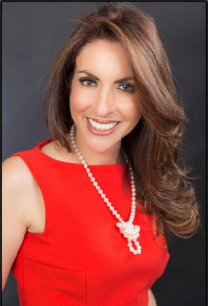  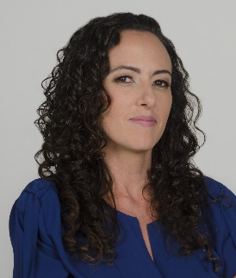  To know and to practice some techniques proper to the dramatic art, and more particularly of theatrical improvisation, which will help us to improve our communicative skills and will make our communication more natural, persuasive and spontaneous
12:30pm - 1:30pm | Lunch
1:30pm - 5:30pm | 2nd Session  Workshop: “The power of words and the body”  by Dra. Anamari Irizarry Quintero & Dra. Camille Villafañe Rodriguez

